Cross-quantilogram: GBPUSD and AUDUSD
Method 20 / daily log returns / expanding quantiles / Alpari D1 full available history

Study setup
Logical pair: GBPUSD , AUDUSD
Broker symbols: GBPUSD_i , AUDUSD_i
Snapshot: 2026-11-03_majors_alpari_D1
Timeframe: D1
Matched return window: 1999-01-05 to 2026-11-02 (UTC bar dates)
Matched return count n: 7228
Dropped unfinished last bar dated 2026-11-03 UTC after a tick-volume check against the prior complete day.
Quantiles: expanding window, min history 252 days
tau in [0.05, 0.2]; k=0..10; headline tau=0.05, k=1
Complete matched rows (Excel): GBPUSD-AUDUSD_CQ_D1.xlsx
Complete matched rows (HTML table): GBPUSD-AUDUSD_CQ_D1_data.html

Method carried forward
The cross-quantilogram rho_tau(k) measures linkage among centered quantile-hit indicators of matched daily log returns of close, ln(close_t / close_t-1). Quotes are not inverted. At each date t, the tau-quantile uses only returns through t (expanding window) after a minimum history of 252 days. Hits are h_t = 1(r_t < q_t) - tau. rho_tau(k) is the normalized cross-product of h_x,t with h_y,t+k. Levels tau in {0.05, 0.20} and lags k=0..10 are pre-specified; headline is tau=0.05, k=1 both directions. Same-sample Pearson r is a side check. This is not causation and not a trading signal.

Results (headline)
rho_GBPUSD->AUDUSD(tau=0.05,k=1): 0.063020
rho_AUDUSD->GBPUSD(tau=0.05,k=1): 0.069201
rho_GBPUSD->AUDUSD(tau=0.20,k=1): 0.032078
rho_AUDUSD->GBPUSD(tau=0.20,k=1): 0.030268
Pearson r: 0.539048

CQ table (tau=0.05)
k | rho_GBPUSD_to_AUDUSD | n_GBPUSD_to_AUDUSD | rho_AUDUSD_to_GBPUSD | n_AUDUSD_to_GBPUSD
0 | 0.27937558 | 6977 | 0.27937558 | 6977
1 | 0.06301974 | 6976 | 0.06920118 | 6976
2 | 0.03519583 | 6975 | 0.05064954 | 6975
3 | 0.03827914 | 6974 | 0.04446067 | 6974
4 | 0.02281776 | 6973 | 0.04445329 | 6973
5 | 0.04135509 | 6972 | 0.03208265 | 6972
6 | 0.03516601 | 6971 | 0.04443852 | 6971
7 | 0.05370372 | 6970 | 0.02897683 | 6970
8 | 0.05369641 | 6969 | 0.03824198 | 6969
9 | 0.02587091 | 6968 | 0.04132546 | 6968
10 | 0.01968152 | 6967 | 0.02895432 | 6967

Conclusion
Headline tau=0.05, k=1 for GBPUSD and AUDUSD: rho_GBPUSD->AUDUSD = 0.0630; rho_AUDUSD->GBPUSD = 0.0692. At tau=0.20, k=1: 0.0321 and 0.0303. Same-day tau=0.05 rho(k=0) = 0.2794. Pearson r = 0.5390. This is quantile-hit linkage, not a trading signal.

Charts
Daily closes

Daily log returns

Cross-quantilogram tau=0.05
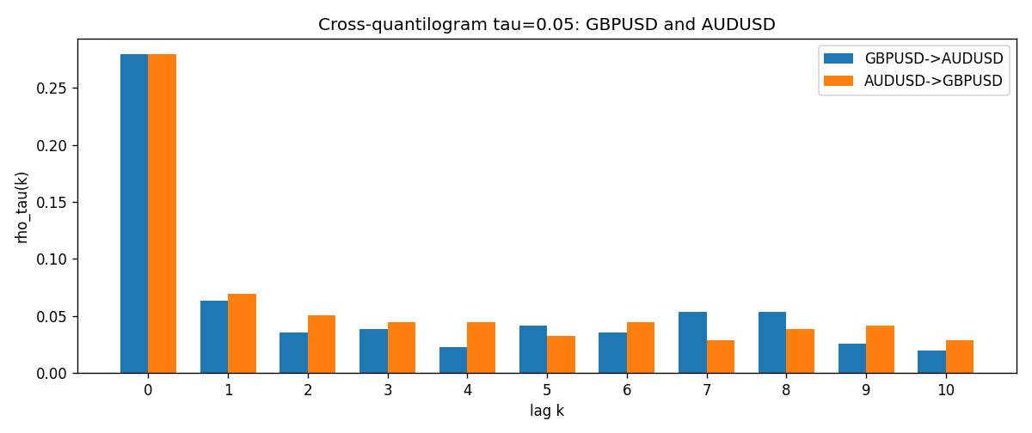

Data report
Matched rows and the CQ sheet are in the sibling Excel workbook named GBPUSD-AUDUSD_CQ_D1.xlsx. Embedding all rows as a Word table is impractical; this file holds column summaries and the first and last 15 matched rows.
Columns: time, GBPUSD_open, AUDUSD_open, GBPUSD_high, AUDUSD_high, GBPUSD_low, AUDUSD_low, GBPUSD_close, AUDUSD_close, GBPUSD_tick_volume, AUDUSD_tick_volume, GBPUSD_spread, AUDUSD_spread, GBPUSD_real_volume, AUDUSD_real_volume, GBPUSD_log_return, AUDUSD_log_return, GBPUSD_h_t005, AUDUSD_h_t005
Column summaries (matched calculation rows)
column | count | mean | std | min | 25% | 50% | 75% | max
GBPUSD_open | 7228 | 1.5166822 | 0.21834818 | 1.06854 | 1.3254025 | 1.51196 | 1.63237 | 2.1066
AUDUSD_open | 7228 | 0.75192541 | 0.13534725 | 0.4785 | 0.66102 | 0.7315 | 0.8091975 | 1.10284
GBPUSD_high | 7228 | 1.5229801 | 0.21891417 | 1.08366 | 1.3300275 | 1.518725 | 1.638825 | 2.1161
AUDUSD_high | 7228 | 0.75597511 | 0.13590934 | 0.4878 | 0.664695 | 0.734945 | 0.81552 | 1.10795
GBPUSD_low | 7228 | 1.5103473 | 0.21757706 | 1.03518 | 1.32009 | 1.50469 | 1.624985 | 2.0983
AUDUSD_low | 7228 | 0.74786335 | 0.13465689 | 0.4775 | 0.6577 | 0.72762 | 0.804475 | 1.0975
GBPUSD_close | 7228 | 1.5167386 | 0.2183035 | 1.06879 | 1.32568 | 1.51203 | 1.6324775 | 2.1065
AUDUSD_close | 7228 | 0.75196864 | 0.13532707 | 0.4786 | 0.6611875 | 0.731775 | 0.809315 | 1.10169
GBPUSD_tick_volume | 7228 | 94565.268 | 153330.81 | 62 | 9974.5 | 52775.5 | 91622.5 | 1273370
AUDUSD_tick_volume | 7228 | 77126.179 | 137934.11 | 109 | 5406 | 43250.5 | 71246.75 | 1234623
GBPUSD_spread | 7228 | 27.003182 | 19.183813 | 0 | 11 | 20 | 50 | 50
AUDUSD_spread | 7228 | 30.855562 | 16.875394 | 0 | 13 | 30 | 50 | 50
GBPUSD_real_volume | 7228 | 3.5428062e+09 | 8.4280615e+10 | 0 | 0 | 0 | 0 | 2.4038164e+12
AUDUSD_real_volume | 7228 | 5.2225089e+09 | 1.2514647e+11 | 0 | 0 | 0 | 0 | 3.811512e+12
GBPUSD_log_return | 7228 | -2.954e-05 | 0.0056473 | -0.08388241 | -0.00313242 | 3.002e-05 | 0.00317333 | 0.03112653
AUDUSD_log_return | 7228 | 1.629e-05 | 0.00754363 | -0.08602525 | -0.00386494 | 0.00027649 | 0.00415111 | 0.0806166
GBPUSD_h_t005 | 6977 | 0.00116812 | 0.22035632 | -0.05 | -0.05 | -0.05 | -0.05 | 0.95
AUDUSD_h_t005 | 6977 | -0.0035617 | 0.21044745 | -0.05 | -0.05 | -0.05 | -0.05 | 0.95
First 15 matched rows (selected columns)
time | GBPUSD_log_return | AUDUSD_log_return | GBPUSD_h_t005 | AUDUSD_h_t005
1999-01-05 | -0.0028966287 | -0.00080418179 | nan | nan
1999-01-06 | -0.00060452184 | 0.011836351 | nan | nan
1999-01-07 | -0.002118709 | 0.0088650256 | nan | nan
1999-01-08 | -0.0058954193 | 0.00031515916 | nan | nan
1999-01-11 | -0.0056851331 | 0.0072213815 | nan | nan
1999-01-12 | 0.0022657001 | -0.0048608485 | nan | nan
1999-01-13 | 0.0091330396 | -0.0078902098 | nan | nan
1999-01-14 | 0.0019376331 | -0.002696916 | nan | nan
1999-01-15 | -0.0017558204 | 0.007123101 | nan | nan
1999-01-18 | 0.0012112405 | 0.00094592471 | nan | nan
1999-01-19 | 0.0018745281 | 0.0072225153 | nan | nan
1999-01-20 | -0.0049053846 | 0.0012507819 | nan | nan
1999-01-21 | 0.0031518998 | 0.00078094498 | nan | nan
1999-01-22 | 0.0024781662 | -0.012252745 | nan | nan
1999-01-25 | 0.0012066366 | -0.0039591468 | nan | nan
Last 15 matched rows (selected columns)
time | GBPUSD_log_return | AUDUSD_log_return | GBPUSD_h_t005 | AUDUSD_h_t005
2026-10-13 | 0.0036434319 | 0.0035007712 | -0.05 | -0.05
2026-10-14 | -0.0049164679 | -0.0015193215 | -0.05 | -0.05
2026-10-15 | 0.0065976411 | -0.0075447063 | -0.05 | -0.05
2026-10-16 | 0.0037592051 | 0.0033906408 | -0.05 | -0.05
2026-10-19 | -0.0017500314 | 0.0050859986 | -0.05 | -0.05
2026-10-20 | 0.0055923442 | 0.0034620426 | -0.05 | -0.05
2026-10-21 | 0.0012476328 | 0.0036066384 | -0.05 | -0.05
2026-10-22 | 0.00022396082 | -0.0012672558 | -0.05 | -0.05
2026-10-23 | -0.0021146949 | 0.0023765656 | -0.05 | -0.05
2026-10-26 | -0.0024340661 | -0.0032032829 | -0.05 | -0.05
2026-10-27 | -0.0023648393 | 0.0016669876 | -0.05 | -0.05
2026-10-28 | 0.0015771808 | 0.0040915541 | -0.05 | -0.05
2026-10-29 | 0.0035881935 | -0.0040915541 | -0.05 | -0.05
2026-10-30 | 0.0013450605 | 0.0010102376 | -0.05 | -0.05
2026-11-02 | 0.0010971256 | -0.0049184984 | -0.05 | -0.05

